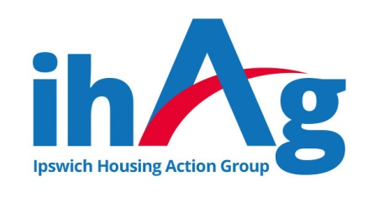
Task Description & Person Specification
ihAg Volunteer Administrator

ihAg values the expertise, knowledge and skills volunteers bring to the organisation, and are committed to offering meaningful opportunities for personal and professional development.

The tasks below can be achieved with training, knowledge and confidence, all of which we intend to give you.

Objective of the role:
To support the “behind the scenes” work of the ihAg services, by providing support with record keeping, collation and distribution of information packs, filing, sorting through donations and other routine admin tasks as directed.

Useful Previous Experience:
Work within an office environment, telephone work, use of a computer, filing or other routine admin duties.

Main Responsibilities:
- Undertake the tasks you are assigned in a timely a manner
- Maintain the highest level of confidentiality in relation to information which is seen as part of the tasks undertaken
- Work as part of the ihAg team and support other team members.
- Participate in training courses and supervision meetings where appropriate.
- Maintain the health and safety of yourself and others in accordance with current legislation.
- Contribute towards the promotion of equality and diversity.

Responsible to:
Service Manager or Senior Staff member within the team – to be confirmed at commencement of arrangement.

Commitment to Hours:
We ask that our volunteers commit to one full day, or two half days per week, for a minimum period of six months.

Essential Skills/Knowledge/Abilities:
- Good understanding of Maths and English.
- Ability to pay close attention to detail and be well-organised.
- Ability to prioritise tasks & work on own initiative once trained.
- Keep accurate records and perform basic admin tasks.

Essential Personal Attributes:
- Methodical, thorough and flexible.
- Self-motivated and enthusiastic.
- Willingness to learn and share experiences.

