A message from our Chief Executive Officer, Jools Ramsey

“I am sad to announce the closure of our specialist Debt and Money Management service from the 31st March 2023.

ihAg have a long history of offering specialist support and advice regarding debt, but over the last few years securing funding for this much needed service has been more and more challenging, and we have been unable to secure funds beyond the end of March.

Alternative, free specialist advice is available from the following agencies:

Stepchange - 0800 138 1111 https://www.stepchange.org/
Money Helper - 0800 011 3797 https://www.moneyhelper.org.uk/
National Debtline - 0808 808 4000 https://www.nationaldebtline.org/
Citizens Advice - 0300 330 1151 https://www.citizensadvice.org.uk/

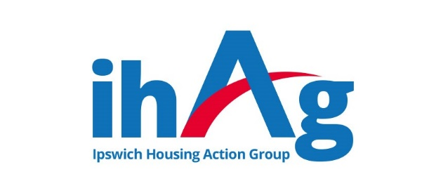
Our Advice Hub and Accommodation services will continue to offer support, advice and guidance to people living with the experience of. or at risk of becoming homeless, including practical day-to-day money management skills”

